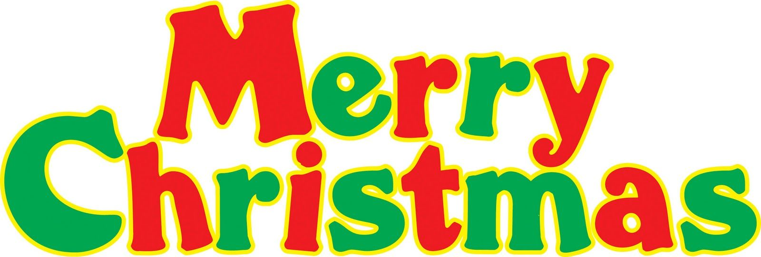

December Menu 2018

BREAKFAST LUNCH

3) Breakfast Bites Beef & Gravy over Rice or Noodles
4) Omelets & sausage Sub Sandwich & Fries
5) French Toast & Ham Salisbury Steak w/Baked Potato
6) Biscuit & Gravy Green Bean Casserole
7) Donuts & Yogurt Sloppy Joes w/Chips & Baked Beans

10) Stuffed Crust Pizza Potato Bowl
11) Turnovers Pork Sandwich & Fries
12) Croissant Sandwich Taco Bar
13) Egg Extravaganza & Meat Soup & Cinnamon Rolls
14) Danish Hot Ham & Cheese w/ Fries

17) Tornadoes Mini Corn Dogs, Chips & Beans
18) Muffins & Cheese Sticks Ham & Mac casserole w/Baked Bean
19) Cinnamon Rolls CHRISTMAS DINNER
20) Burritos Pizza
21) English Muffin Sandwich Cheeseburgers & Fries
24) NO SCHOOL
25) NO SCHOOL MERRY CHRISTMAS
26) NO SCHOOL
27) NO SCHOOL
28) NO SCHOOL

31) NO SCHOOL

** Food Bar and Milk available with the Lunch Meal
** Fruit, Milk and Juice available with Breakfast Meal
** Menu subject to change
** This institution is an equal opportunity provider

